DAY #1 October 29th: Dead Sea and Galilee.
Ein Gedi
https://www.touristisrael.com/ein-gedi-nature-reserve/5529/
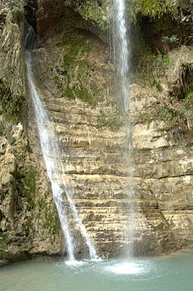
Qumran (Dead Sea Scrolls) https://www.touristisrael.com/qumran/9374/
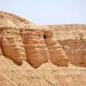
Kalia Beach
http://kaliabeach.com/en/
Evening
Worship and meet with Rania (at Hotel)
Leader of Nazareth House of Prayer
https://www.youtube.com/watch?v=v_T025PIhbk
HOTEL: Sea of Galilee Village https://www.kfarkinneret.com
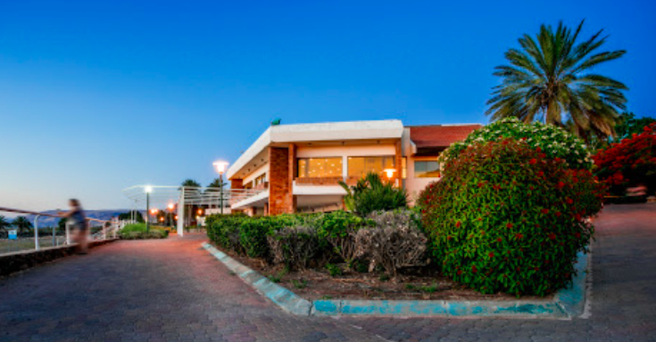

DAY #2 October 30th: Galilee, Carmel and Haifa
Boat Ride on Sea of Galilee.
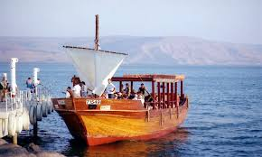
Lunch at En Gev
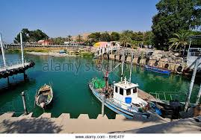
Rosh HaNikra (Caves on border of Lebanon)
https://rosh-hanikra.com/home-en/
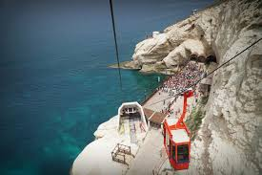
Worship on Mt. Carmel
with Karen Davis (and Ruth)
http://www.carmelcongregation.org.il
HOTEL Dan Panorama, Haifa
https://www3.danhotels.com/HaifaHotels/DanPanoramaHaifaHotel
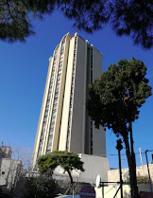

DAY #3 October 31st: Zicron Yaakov & Tel Aviv
First Alliyah Museum
https://www.haaretz.com/israel-news/travel/1.5010252
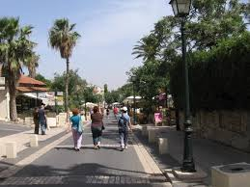
Ramat Ha Nadiv –Gardens
http://www.ramat-hanadiv.org.il/en
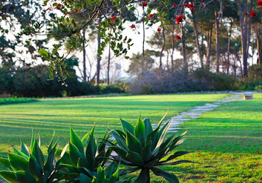
Worship Time in Zicron
at home of Alyosha and Jody Ryabanov
https://www.youtube.com/watch?v=Ds-C4b7wmzY
HOTEL Ruth Daniel Residence, Tel Aviv
http://ruthdanielresidence.com-telaviv.com
